**Exercise 1**

Create a web page with the following using HTML.

• To embed an image map in a web page.

• To fix the hot spots.

• Show all the related information when the hot spots are clicked.

Note:

Store the image (India_map.jpg) in current folder

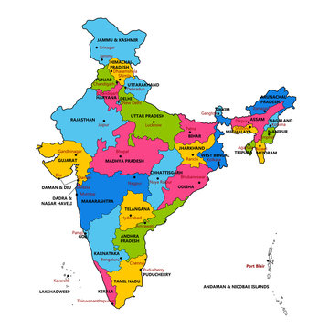

**IDE:** Visual Studio Code

**mymap.html**

<html>

<body>

<img src="india_map.jpg" usemap="#image_map">

<map name="image_map">

<area alt="TamilNadu" title="TamilNadu" href="tamilnadu.html" coords="140,304,17" shape="circle">

<area alt="Karnataka" title="Karnataka" href="karnataka.html" coords="97,240,125,288" shape="rect">

<area alt="Andhra" title="andhra" href="andhra.html" coords="129,250,163,278" shape="rect">

<area alt="Kerala" title="Kerala" href="kerala.html" coords="113,297,124,330" shape="rect">

</map>

</body>

</html>

<!-- https://imagemap.org/ -->

**tamilnadu.html**

<HTML><HEAD>

<TITLE>About Tamil Nadu</TITLE>

</HEAD>

<BODY>

<CENTER><H1>Tamil Nadu</H1></CENTER> <HR>

<UL>

<LI>Area : 1,30,058 Sq. Kms.</LI>

<LI>Capital : Chennai</LI>

<LI>Language : Tamil</LI>

<LI>Population : 6,21,10,839</LI> </UL><hr>

<a href='ImageMap.html'>India Map</a>

</BODY>

</HTML>

**kerala.html**

<HTML>

<HEAD>

<TITLE>About Kerala</TITLE>

</HEAD>

<BODY>

<CENTER>

<H1>Kerala</H1></CENTER>

<HR>

<UL>

<LI>Area : 38,863 Sq. Kms.</LI>

<LI>Capital : Thiruvananthapuram</LI>

<LI>Language : Malayalam</LI>

<LI>Population : 3,18,38,619</LI>

</UL>

<hr>

<a href='ImageMap.html'>India Map</a>

</BODY></HTML>

**andhra.html**

<HTML>

<HEAD>

<TITLE>About Andhra Pradesh</TITLE> </HEAD>

<BODY>

<CENTER><H1>Andhra Pradesh</H1></CENTER> <HR>

<UL>

<LI>Area : 2,75,068 Sq. Kms</LI>

<LI>Capital : Hyderabad</LI>

<LI>Language : Telugu</LI>

<LI>Population : 7,57,27,541</LI>

</UL>

<hr>

<a href='ImageMap.html'>India Map</a>

</BODY>

</HTML>

**Karnataka.html**

<HTML>

<HEAD>

<TITLE>About Karnataka</TITLE> </HEAD>

<BODY>

<CENTER><H1>Karnataka</H1></CENTER>

<HR>

<UL>

<LI>Area : 1,91,791 Sq. Kms</LI>

<LI>Capital : Bangalore</LI>

<LI>Language : Kannada</LI>

<LI>Population : 5,27,33,958</LI>

</UL>

<hr>

<a href='ImageMap.html'>India Map</a>

</BODY>

</HTML>